“Heaven’s Light is Our Guide”

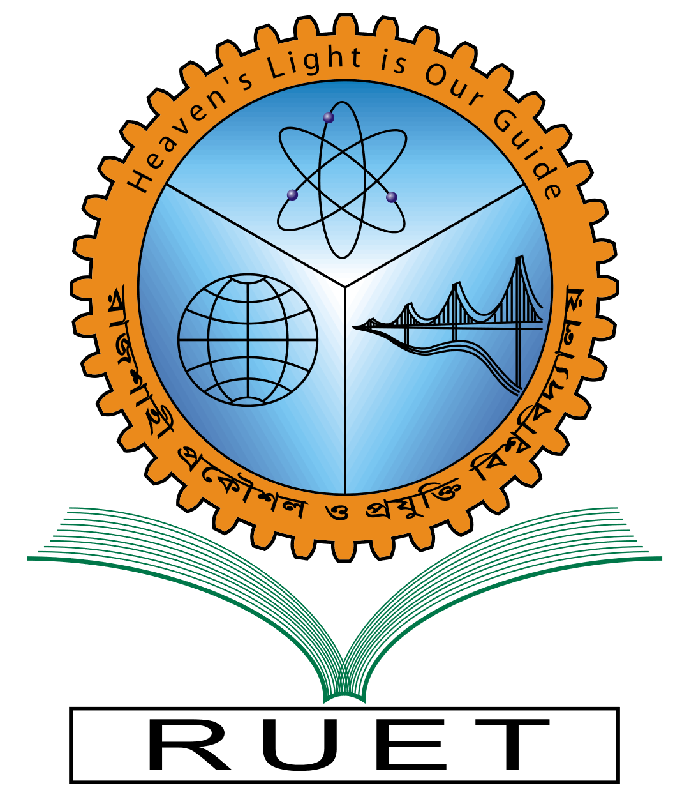

**Rajshahi University of Engineering & Technology**

Department of Computer Science & Engineering

Assignment

|  |  |
| --- | --- |
| Course Code: | CSE 1203 |
| Course Name: | Object Oriented Programming |
| Assignment No: | 01 |
| Assignment Name: | C++ & Java Program |
| Date of Assignment: | December 10, 2022 |
| Date of Submission: | December 26, 2022 |

|  |  |
| --- | --- |
| Submitted By: | Submitted To: |
| Name: Tonmoy | Md. Shahid Uz Zaman |
| Section: A | Professor |
| Roll: 2003027 | CSE, RUET |
| Year: 1st year, Even Semester |  |